

***101***

***Training Manual***

***Overview & Gaining Access***

**REDCap Overview:**

REDCap is a browser-based, metadata-driven electronic data capture software created by Vanderbilt University. The REDCap Consortium is composed of nearly 900 active institutional partners from more than 70 countries. Programming, networking or database experience is not needed to use REDCap. It is designed to use simple interfaces that handle these details automatically. REDCap is secure and web-based: you can input data or build an online survey or database from anywhere in the world over a secure web connection with authentication and data logging. REDCap allows multi-site access for research that uses multiples sites and institutions. OUHSC maintains three instances of REDCap: the Biomedical and Behavior Methodology Core Customization Instance, the Enterprise Instance, and the Development Instance.

**Gaining Access to REDCap:**

Access to the three REDCap instances is available to any individual having login credentials (username and password) issued by the University of Oklahoma Health Sciences Center (OUHSC). When collaborating with researchers outside of OUHSC, the REDCap Project Owner will need to request an OUHSC ID for any member of their research team who does not have OUHSC login credentials. This request must go through OUHSC campus IT. Once an individual has an OUHSC username and password, they can log in to one of the three REDCap instances:

<https://miechvprojects.ouhsc.edu>

<https://rcapdev.ouhsc.edu>

<https://redcap.ouhsc.edu>

**Logging into REDCap:**

After navigating to the appropriate REDCap instance, users will see the following login screen:

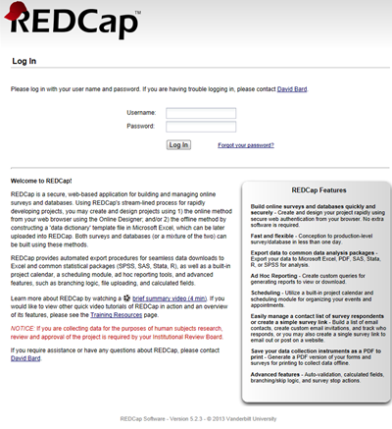

The REDCap username and password are the individual’s OUHSC username and password. When logging in for the first time, users will see a screen to edit their user profile:

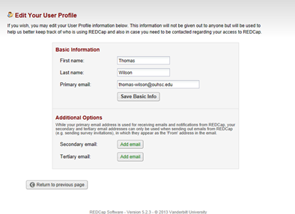

A profile confirmation link will be e-mailed to users automatically after they complete their user profile. When the link arrives in the user’s inbox, they can click on the link and they will be ready to login and begin using REDCap.

After successfully logging into REDCap, users will see the menu below:

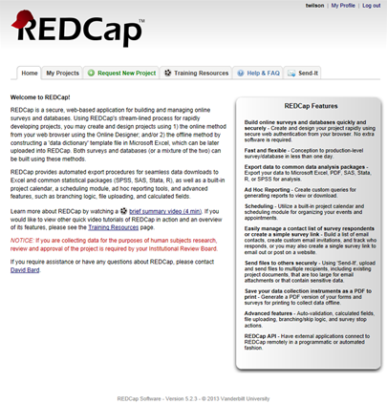

Users can edit/update their profile information at anytime. Clicking on the “My Profile” link in the upper right hand corner of the REDCap login screen takes users to the appropriate screen. Next to the “My Profile” link is the “Log Out” link for users to click when they are finished working in REDCap.

***REDCap’s Main Menu***

**Navigating the REDCap Menu:**

The REDCap menu has 6 tabs:

Home

My Projects

Request New Project

Training Resources

Help & FAQ

Send-It

**Home:** This tab gives a brief overview of REDCap and it’s features.

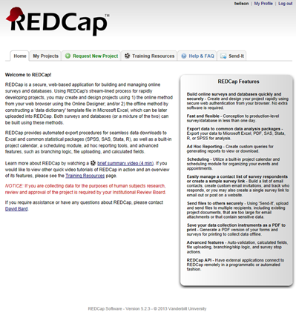

**My Projects:** This tab shows a list of all projects a user has access to view (in this example, the user only has access to the public training projects). The list of projects will vary depending on the user.

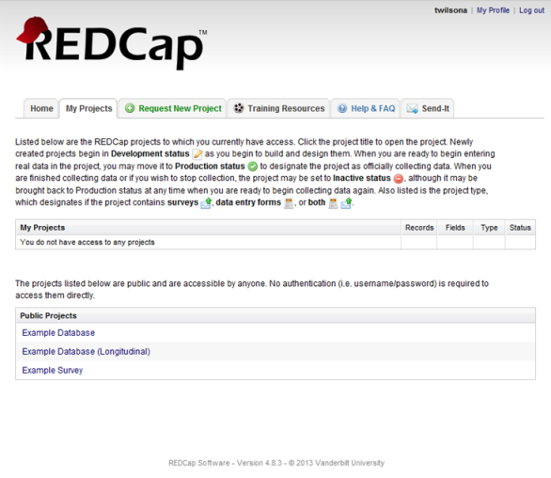

**Request New Project:** This tab contains the steps a user must follow to request the creation of a new project.

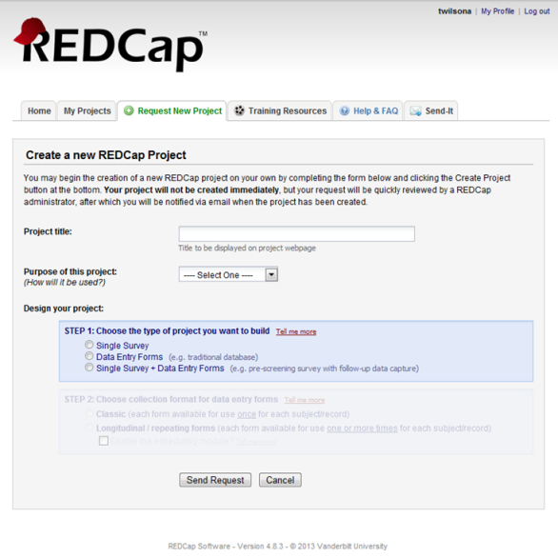

**Training Resources:** This tab contains the library of Vanderbilt University REDCap training videos and resources.

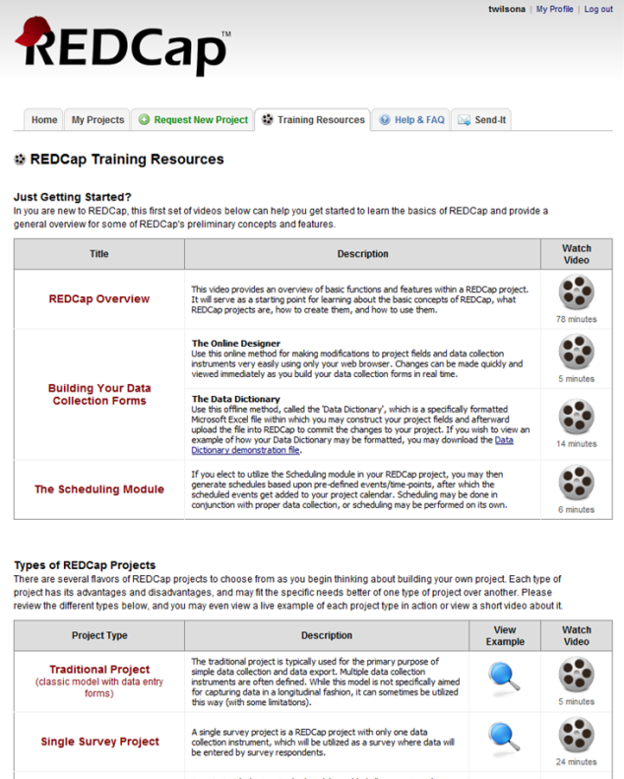

**Help & FAQ:** This tab contains many questions regarding the features and use of REDCap.

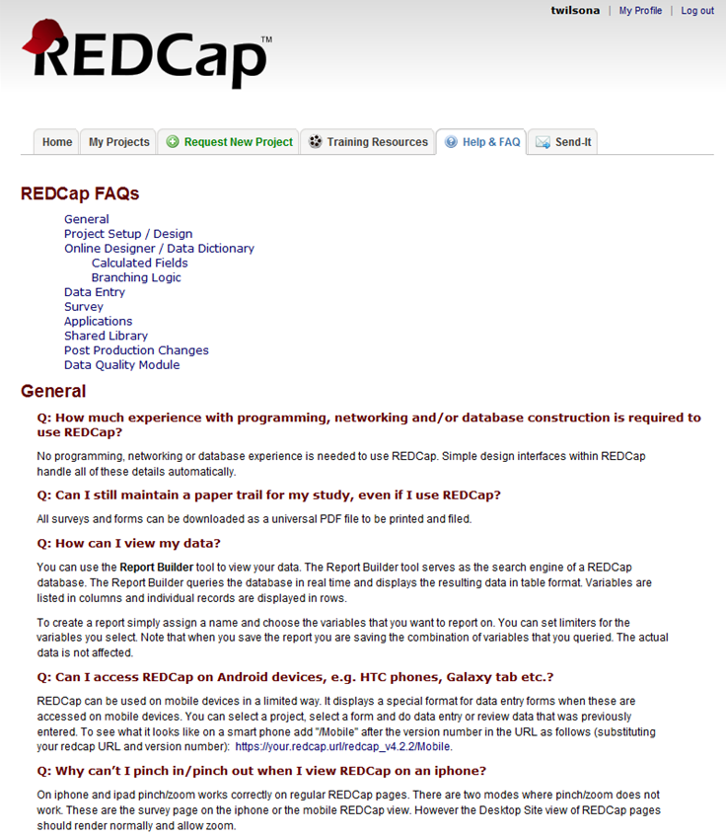

**Send-It:** The send-it tab is a secure data transfer application. It allows users to upload files and then designate multiple recipients to downlaod the file in a secure manner.

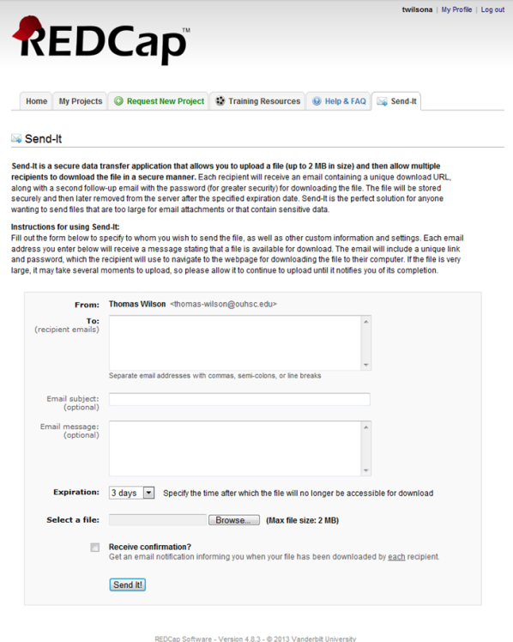

***REDCap’s Project Menu***

**Navigating the Project Menu:**

A user’s project menu is customized based upon the user right’s that are assigned to them. The project menu shown here is for a data entry user who has minimal rights. The REDCap 201 course offers a more complete look at the project menu.

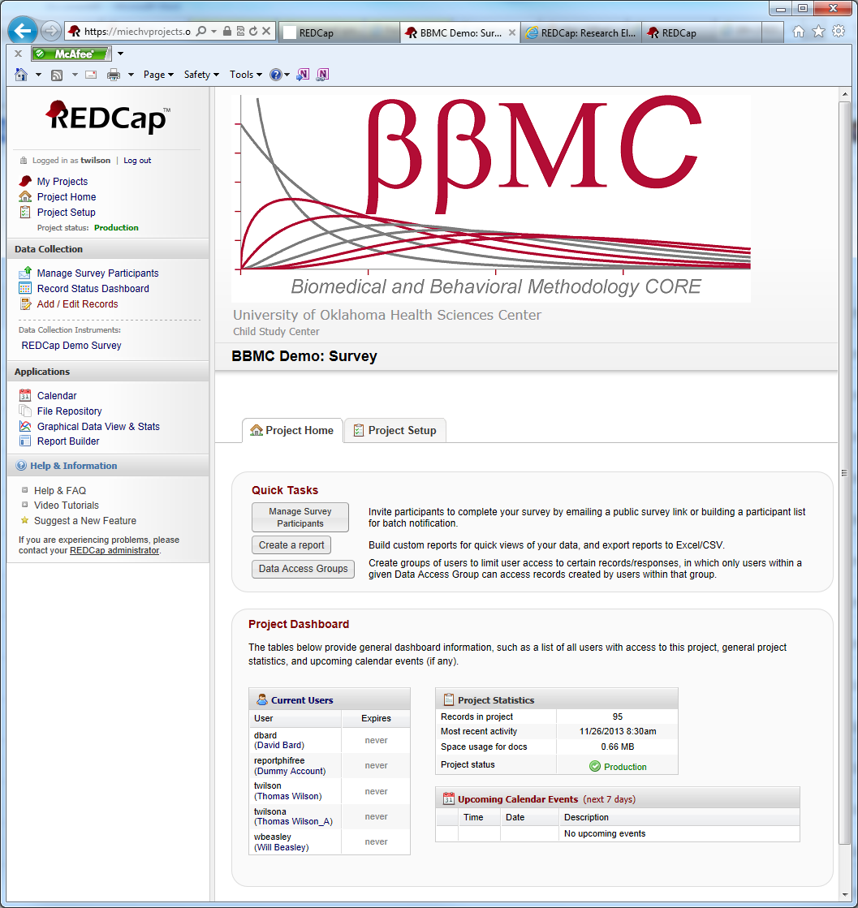

The first block of menu items contain the following information:

* Username and link to logout
* My Projects: Returns the user to the main REDCap menu
* Project Home: Links user to the main page for a specific project (the Project Home page is shown below.
* Project Setup: Takes the user to the settings page for this project.



**Data Collection:** This portion of the the REDCap Project Menu contains links for the data collection aspect of a project. Users will utilize these menu options when recording data.

* Manage Survey Participants: This link navigates users to the menu for options on sending surveys to participants.
* Record Status Dashboard: the Dashboard shows the status of all records that have been collected (Complete, Unverified, Incomplete, Completed Survey Response, or Partial Survey Response)
* Add/Edit Records: Use this link to add a new record to the project or to edit responses (must have appropriate permissions to do edit a response)
* Data Collection Instruments: A list of all data collection instruments included in this project. In this example, there is only one data collection instrument named: “REDCap Demo Survey”.



**Applications:** Lists all extra functions that a user can access.

Calendar: This is the REDCap built-in calendar function. You can add appointments, create schedules for participants (if project is longitudinal), etc.

File Repository: The file repository is a place to store important study documents in a centralized location. Examples of documents include: blank consent forms, study fliers for advertisement, study mailers, etc. Do NOT store signed consent forms in this locations.

Graphical View and Stats: Allows a user to create basic univariate bar graphs and pie charts.

Report Builder: Gives users the ability to create simple reports. Examples, include: showing a list of all female participants, sorting all participants alphabetically, etc.



***Data Collection Instruments***

***&***

***Data Entry***

**REDCap’s Data Collection Instruments:**

REDCap utilizes two types of data collection instruments.

* Survey: A survey is one of the two types of data collection instruments that REDCap utilizes. You can have multiple surveys within a REDCap project. A REDCap survey can be e-mailed to individual participants where they are given unique “Private Survey URL’s” or a survey can be made public. The public survey creates a “Public Survey URL” that can be posted on a website or e-mailed to participant. Private surveys can only be filled out one time and the REDCap project owner can determine which participants have responded to the survey. Public surveys can be filled out multiple times and has no built-in functioning to determine which participants have responded.
* Form: A form is the other type of data collection instrument within REDCap. Its intended use is in a clinical setting where a researcher enters the data into REDCap. Multiple forms can be used in a REDCap project.

REDCap allows projects to use both surveys and forms for data collection.

**Data Entry (Survey):**

To enter a new record into a REDCap project, click on the link under “Data Collection Instruments:” In this example it is “REDCap Demo Survey”.

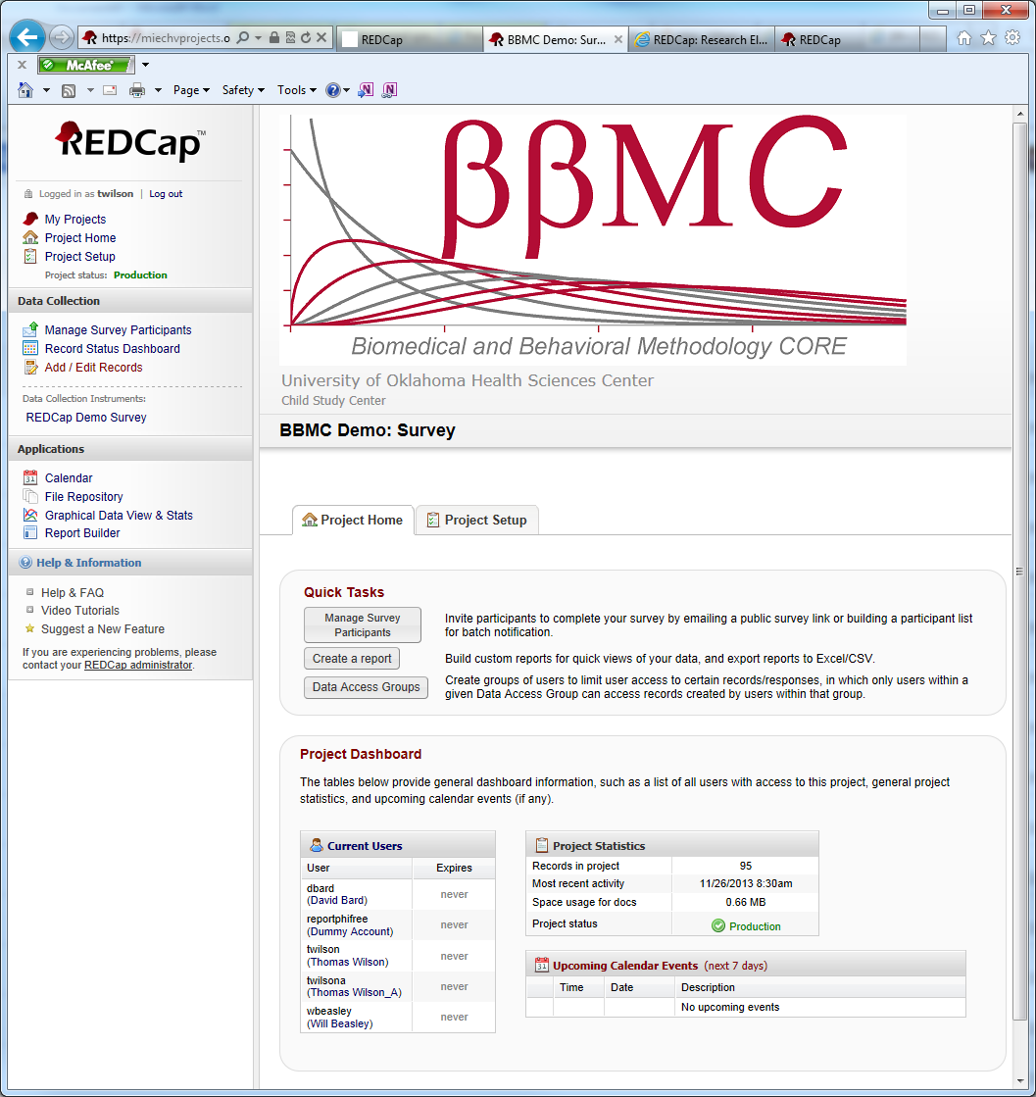

You will be taken to a new screen (shown below).

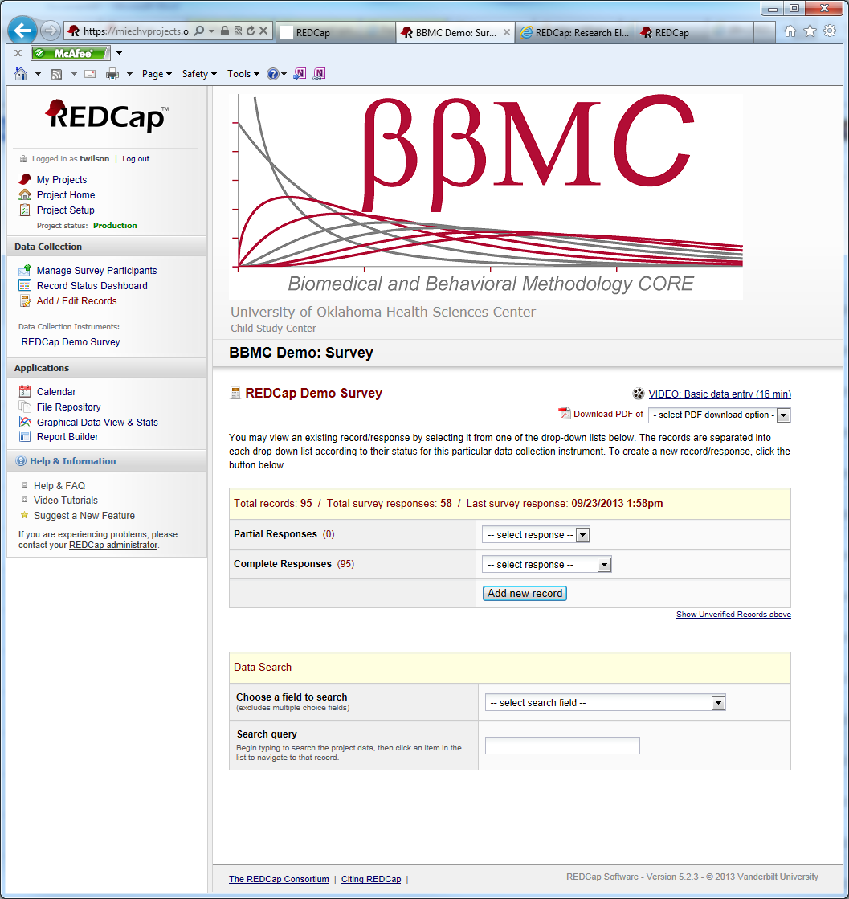

Click on the “Add new record” button. This will navigate you to the data entry page. You will be able to enter values for the questions in your data collection instrument. At the end of your data collection instrument, you will have the following options under Form Status:

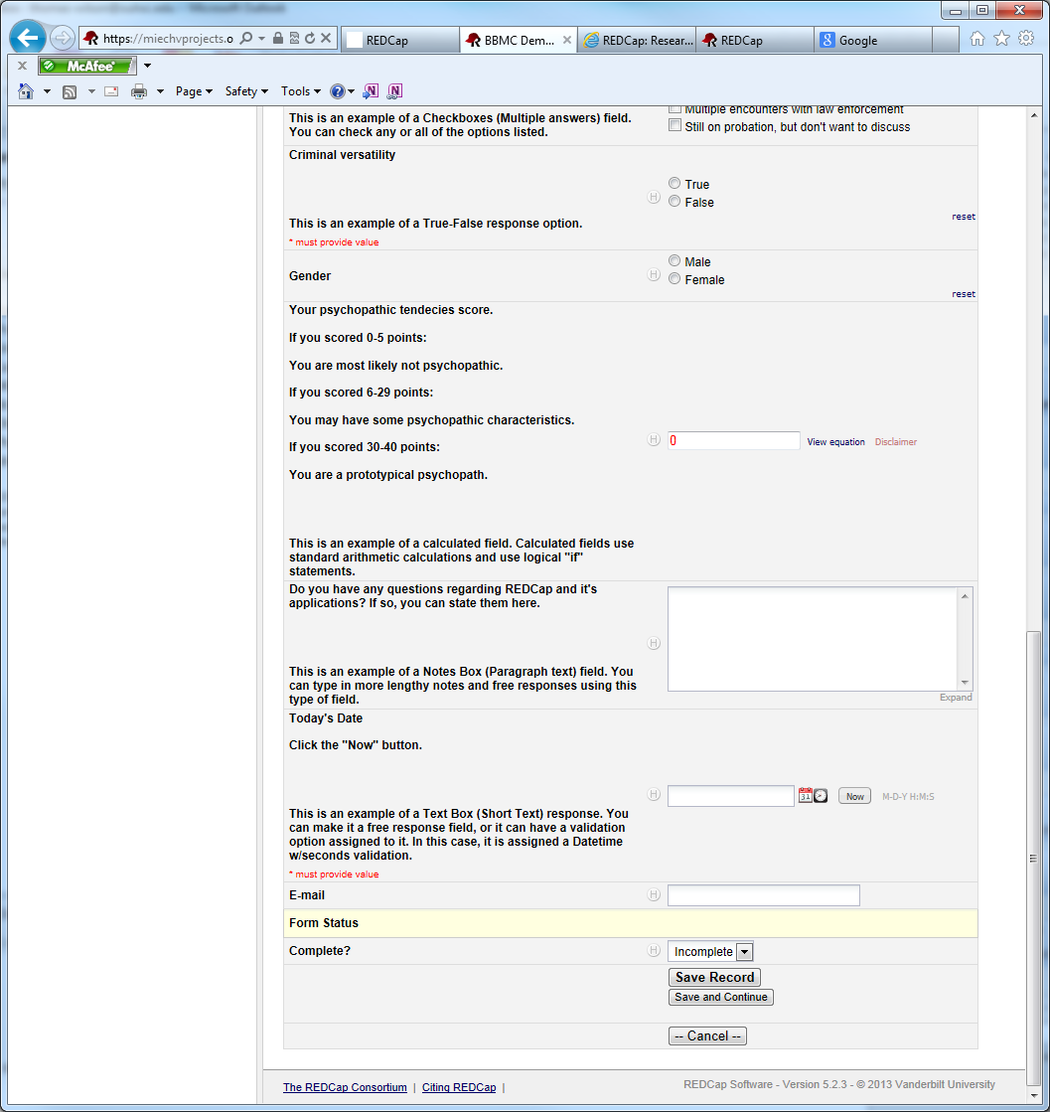

Complete?

* Incomplete
* Unverified
* Complete

Choose the option that best reflects the status of the data collection instrument. You also have the following buttons to complete data entry.

* Save Record: Save the record and exits the data collection instrument.
* Save and Continue: Saves the record and stays in the data collection instrument.
* Cancel: Exits the data collection instrument without saving any changes.

This example used a Survey Data Collection Instrument. If a project utilizes Data Collection Forms, the data entry process is the same.

***Report Builder***

**Report Builder:**

The report builder in REDCap allows users to create quick ad hoc reports for various uses. Clicking on the Report Builder link in the Applications section takes the user to this screen:

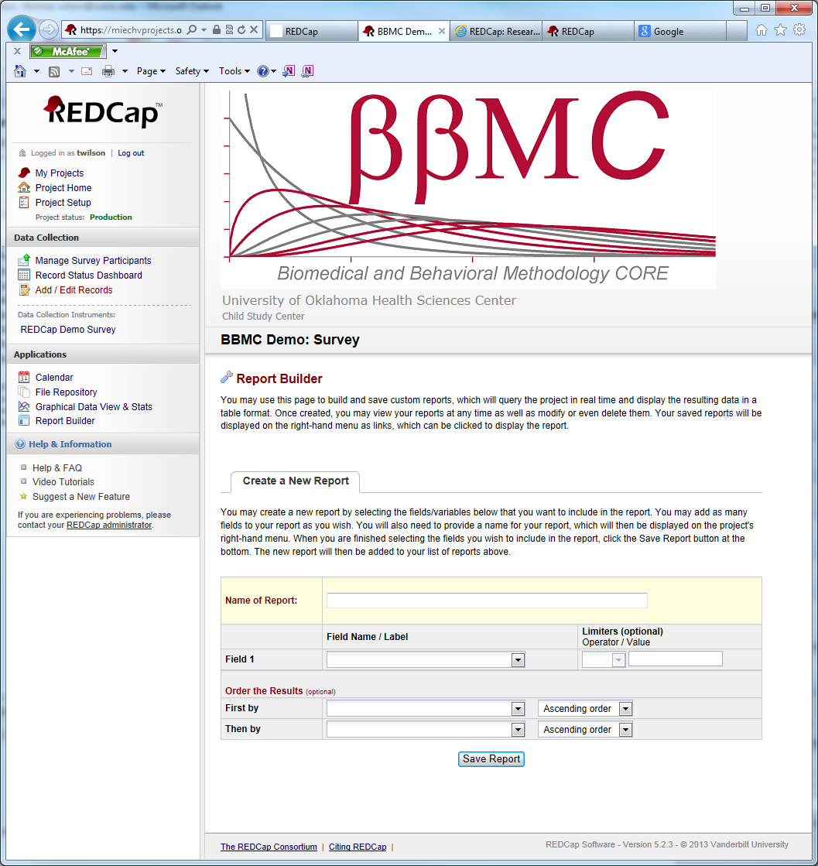

When building a report users have the following options:

* Name of Report: Users can custom name the report to reflect the content it contains
* Fields: Initially, the report builder will only show “Field 1”. Once you use the drop down menu to choose which field you wish to include in the report, REDCap will automatically add “Field 2” below “Field 1”. REDCap will continue to do this for as many fields as you wish to include in the report.
* Limiters: You can limit the report based on the fields you choose. For multiple choice fields, you have the options of “=” and “not =”. Numeric fields can be limited by “=”, “not = “, “<”, “<=”, “>”, and “>=”.
* Order the Results: Users can sort reports by up to two different variables with the option of either ascending or descending sorts.

**Example:**

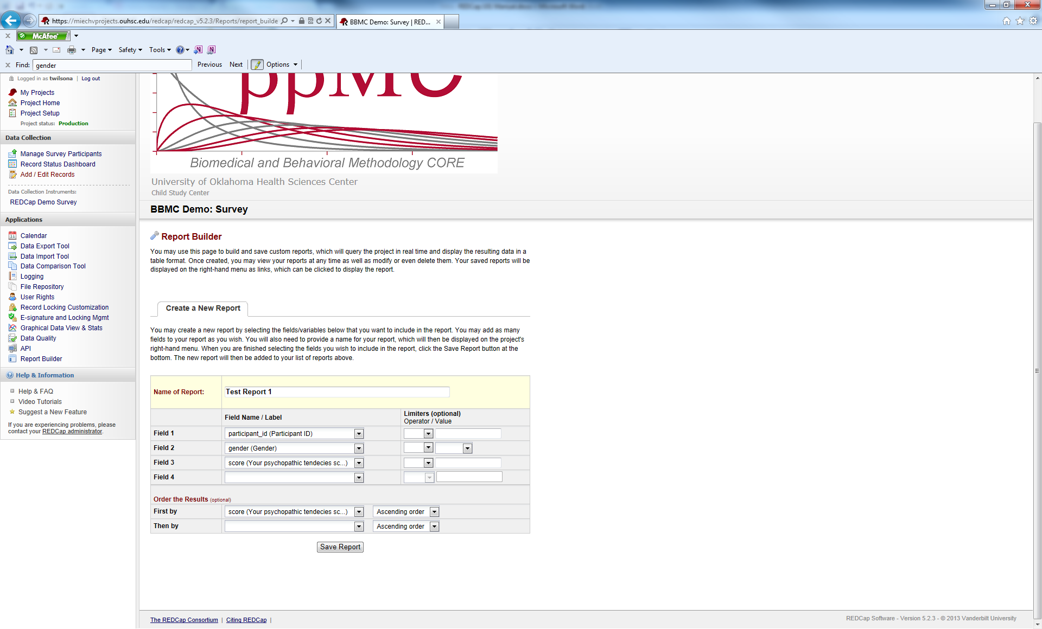

In this example, we are creating a report named “Test Report 1”. The variables participant_id, gender, and score are included in the report and it will be sorted on the variable score.

Once the report has been saved, users will see the following screen:

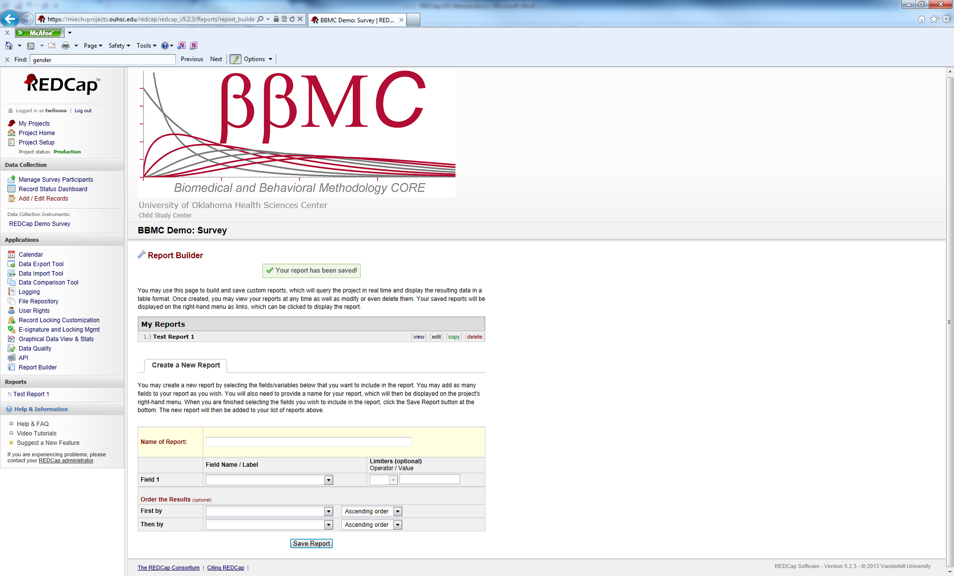

Users will see a list of all reports that have been created. In this instance, there is only 1 report (Test Report 1). Users also have the following options:

View: Allows users to see the current results of the report. Reports are updated automatically in real-time.

Edit: Users can make changes to the report.

Copy: Users can copy a report in its entirety.

Delete: Delete the report. If deleted, there is no “recycle bin” for users to recover the report. It is gone forever and will have to be recreated if a users wishes to use the report again.

**View:**

When viewing a report, it will show you the results and other options:

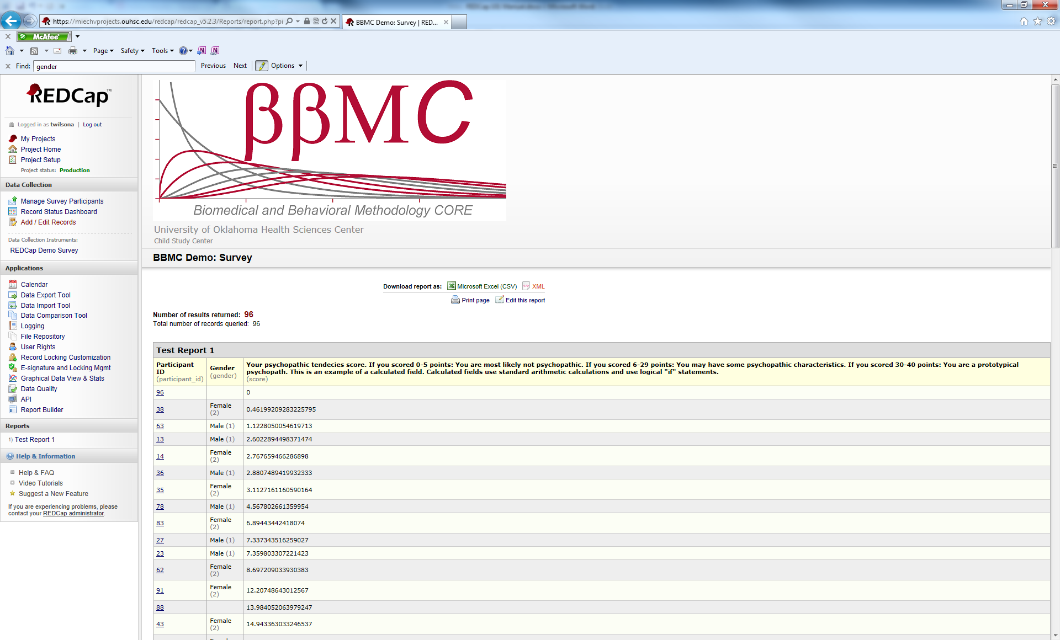

The report results show the Data Labels (what is seen when a survey is taken or a form is completed) in bold. The variable names are shown below the Data Labels. In this example, the column shows Participant ID as the data label and participant_id as the variable name.

Users are given two download options for reports: Microsoft Excel (CSV) and XML. Also, users can print the page and edit the report from this screen.

Congratulations! You have completed the REDCap 101 course. When you are ready, you will need to take the REDCap proficiency test. The instructor will e-mail you a link to take the test. Thank you for you participation.